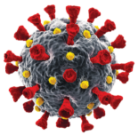 | Omicron Virus 2022
Forum Name |  | Make of Pistol Used | Calibre | 6yd Only | Stance | Total
Forum Name |  | Make of Rifle Used | Calibre | 6yd / 10m | Stance | Total
